**Chatbot UI**

I need a chatbot UI created. The chatbot script will be provided. The chatbot UI must be modern with clean lines and responsive on across all devices.

**To be designed:**

The button to access the chat bot must be similar to this:

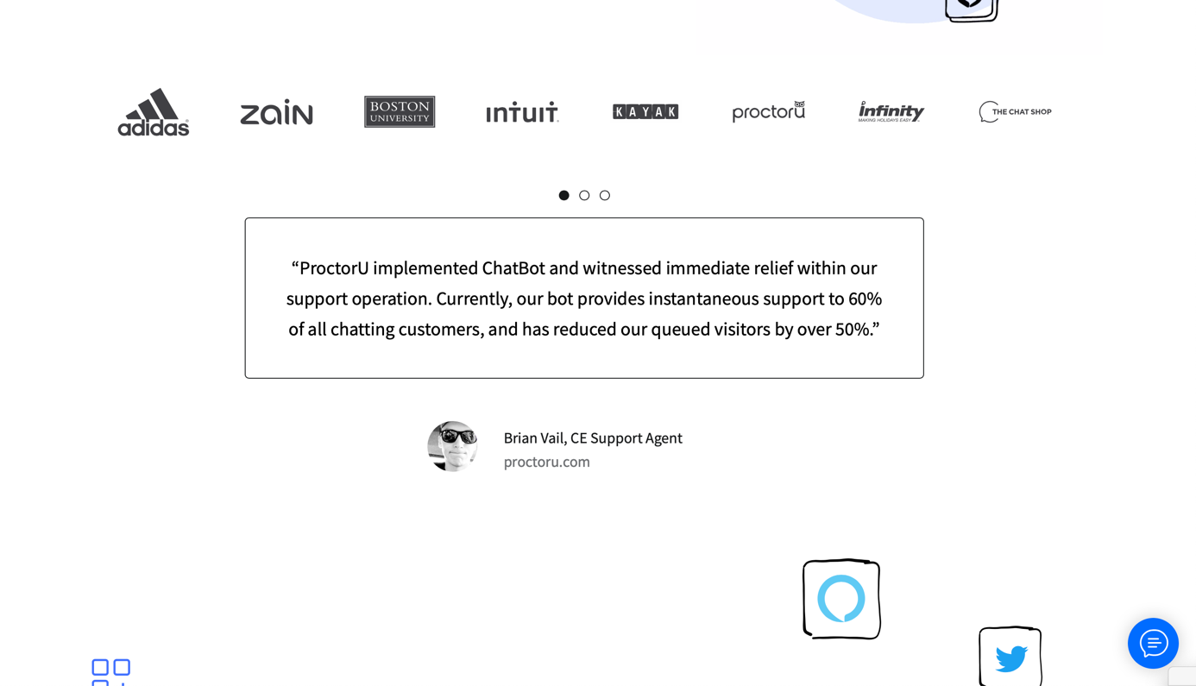

This button should be created to be able to access the chatbot.

**Chat UI:**

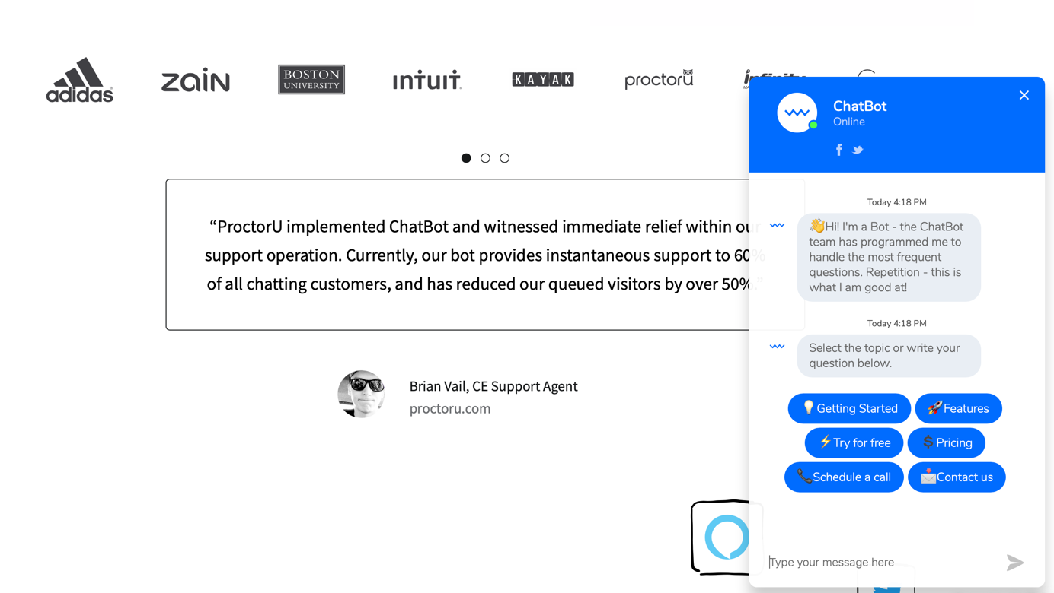

When you then click on the blue button the chat bot then appears as above. As part of the design you also need to implement emojis and allow for buttons to be displayed as part of the chatbot response as shown above.

E.G the response from the chatbot might be a smiley face this should then render as a smiley emoji to the end user.

E.G the response from the chatbot might be a button that takes the end user to another page. This should appear as a button to the end user rather than a script.